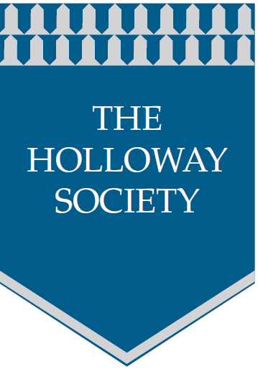
The Holloway Society
Persequimur allecibus rubrum in cavernis leporis
Please complete all the sections of this form to assist us with your application to become a member of the Holloway Society. All information will be held by the Holloway Society and will remain confidential. Please return the form to the Secretary, The Holloway Society, Secretary@HollowaySociety.org.uk

Your Details
Title ................. First Name(s) …................................ Surname..........................................
Home Address ……………………………………...................................................................
....................................................................................................... ......... Post Code …………............................
Home Telephone No. ................................................. Mobile No. ………………........................................
E-mail Address ……………..................................................................................................................................
Date of Birth ………….......................................................................
Do you consider yourself to have a disability? Yes No (Please tick)
If yes, please give details ………………………………………………………………………………………………

Type of Membership (Membership will begin when payment and the completed application form have been received and the Executive Committee approves the Member)

Member A subscription paying member who is willing to volunteer to actively participate in the work of the Society

and who will be able to vote at meetings. Please see details overleaf:-

Associate Member A subscription paying member who will pay the yearly subscription to support the Society

but will not have a vote but may still speak at meetings

Subscription £10 enclosed Cash Cheque Bank Transfer
Bank Details: To be advised

Tick Box to Confirm
Date Transferred
Full name of the account holder transferring funds

Volunteer Opportunities
Please tick the box for the type of roles that may be of interest to you.
Genealogy History Photography

Heritage Writing Researching

Architecture Cover Art Journalism

Catalogue Creation Book Design Database Design

Documentary Film Making Publishing HTML Design

NOTE We can get free short courses in many of these topics and encourage members to learn new skills

Experience, Skills and Interests
Please tick the box that describes any experience or skills that you could use as a volunteer of the Society
Documentary Film Making Journalism Photography

Database Design Publishing Researching

HTML Web Design Cover Art History

Catalogue Creation Architecture Genealogy

Book Design Heritage Writing

Other

Please give details of other experience, skills or interests that may be useful as a volunteer.
..............................................................................................................................................................................................
..............................................................................................................................................................................................
..............................................................................................................................................................................................
..............................................................................................................................................................................................
Society Use Only
Date Payment Received | Payment Type | Membership No.

